Zambia Results
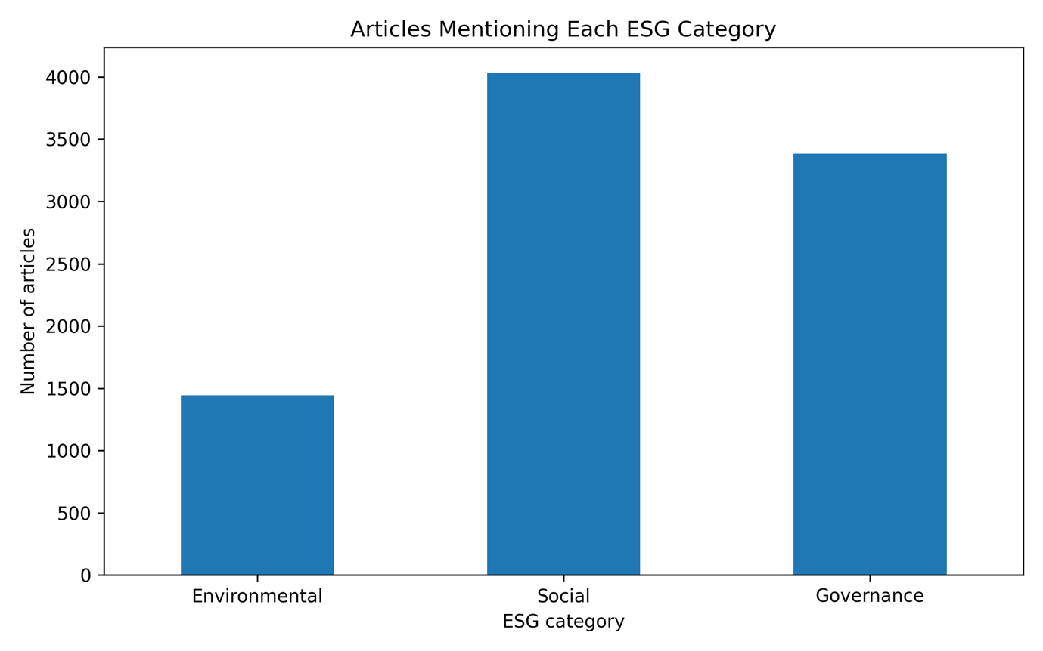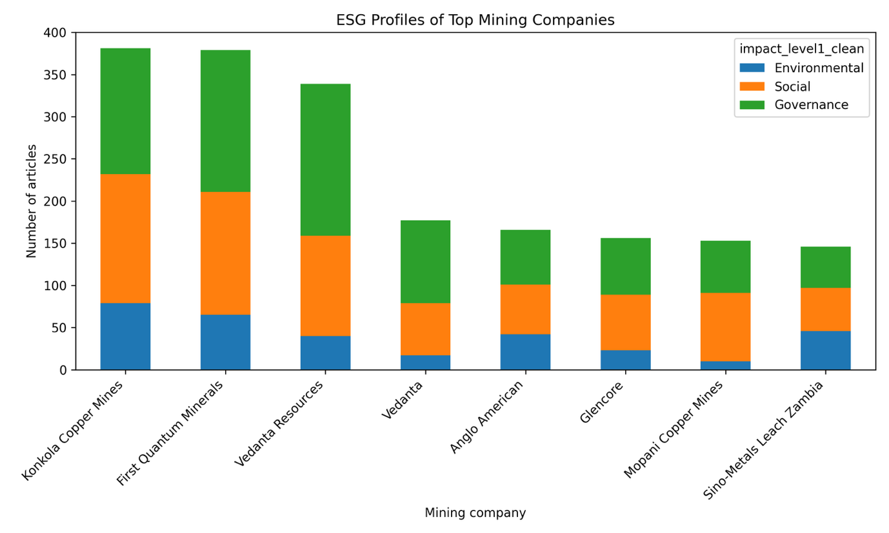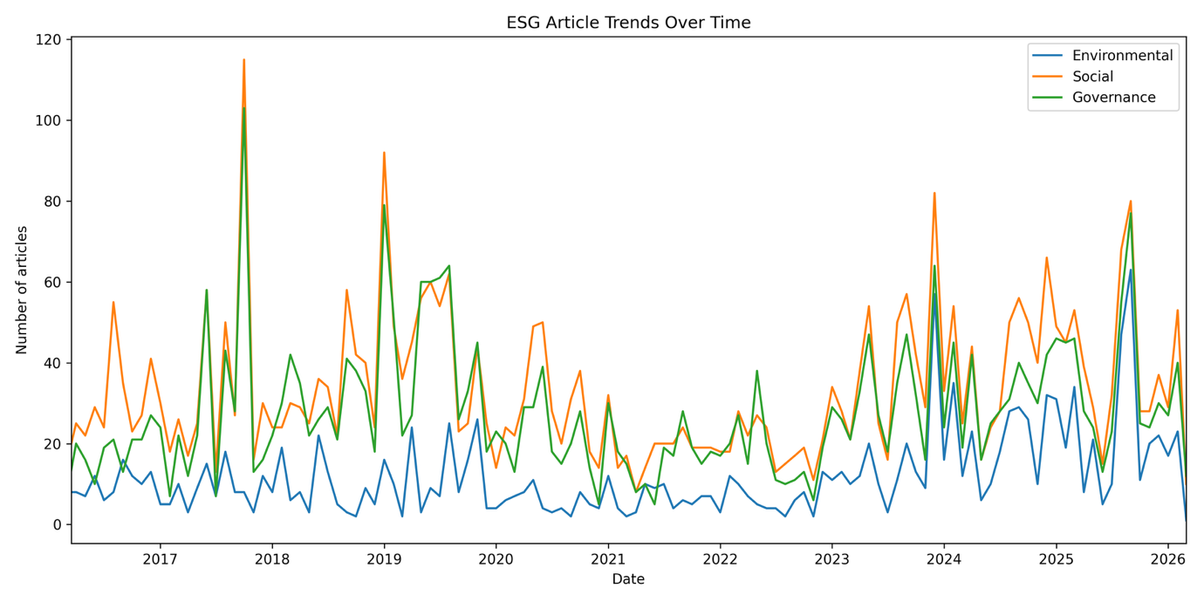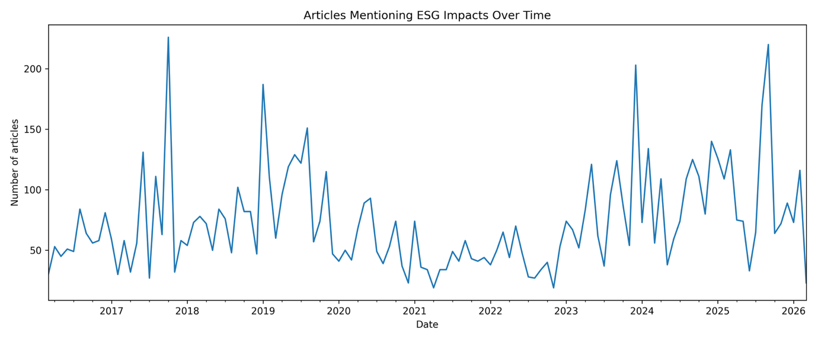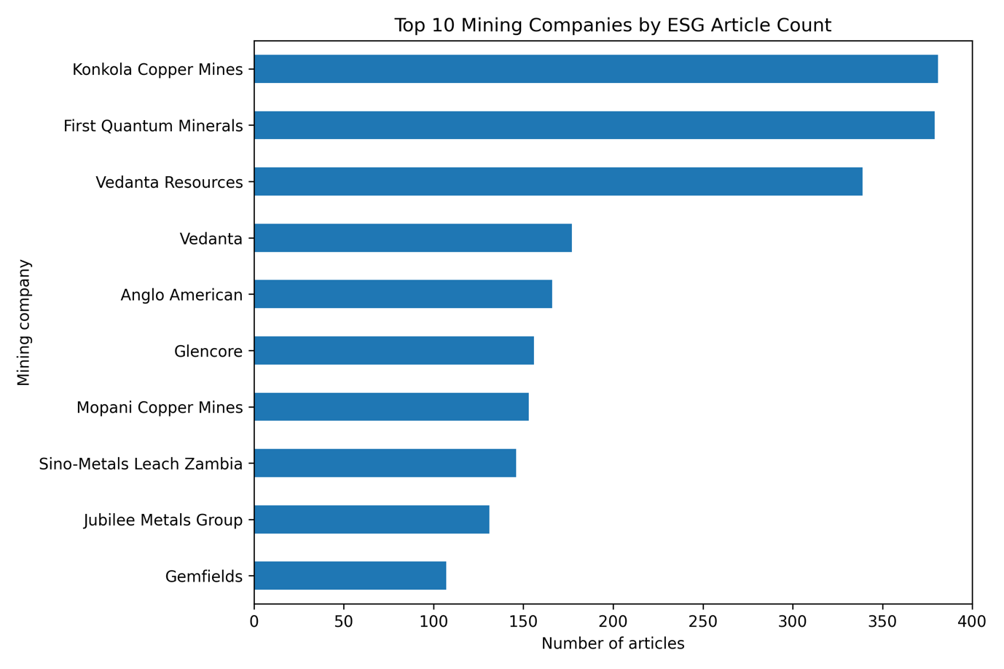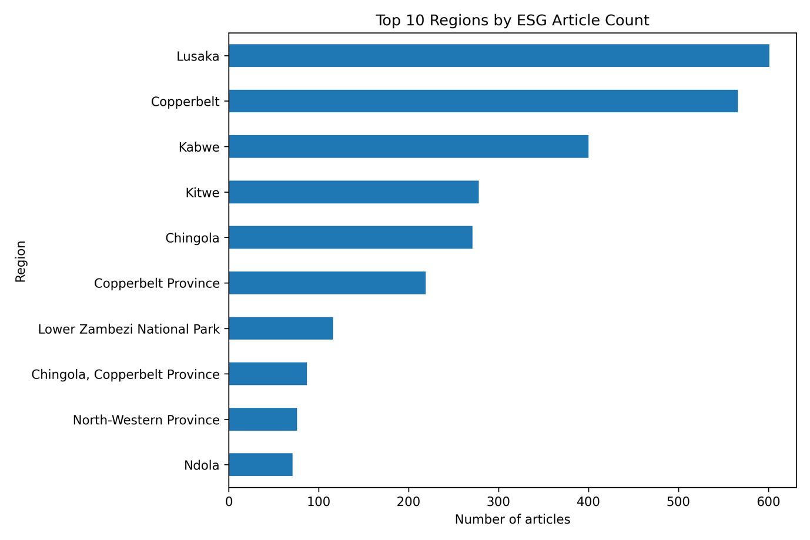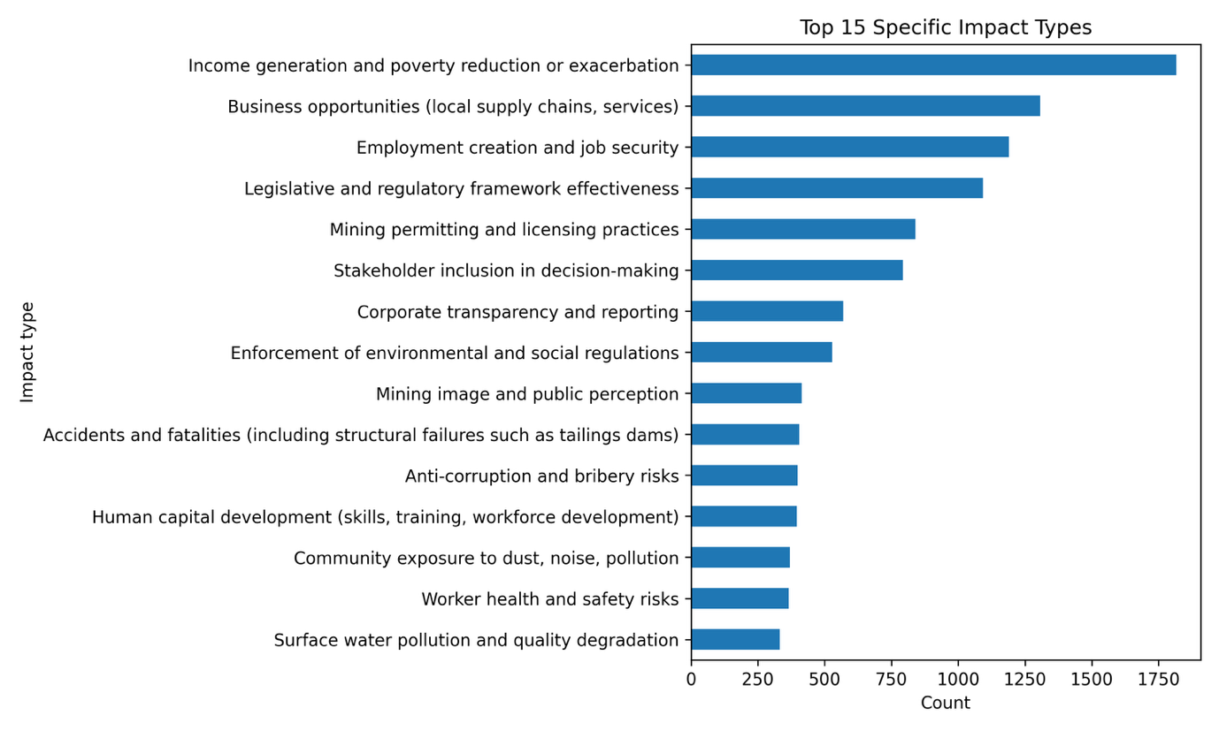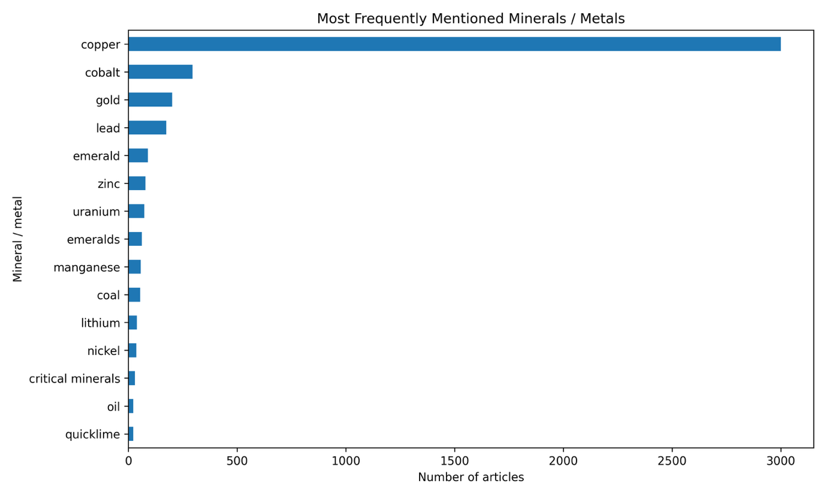

=== HEADLINE STATS ===
Total article rows: 5142
Total unique articles: 5133
Total impact rows: 17200
Total valid ESG impact rows: 17060
Unique articles with at least one impact: 5133

=== ARTICLE-LEVEL ESG CATEGORY COUNTS ===
count pct
Environmental 1443 16.3
Social 4035 45.5
Governance 3382 38.2

=== TOP IMPACT LEVEL 2 ===
impact_level2
Livelihoods & Economy 5041
Regulation, Compliance & Institutions 2586
Health, Safety & Well-being 1471
Transparency & Accountability 1379
Land, Soil & Geology 1024
Stakeholder Engagement & Rights 924
Equity, Rights & Vulnerable Groups 833
Water Resources 810
Reputation & Social License 806
Living Conditions & Social Fabric 788
Air & Climate 619
Biodiversity & Ecosystems 342
Risk Management & Long-Term Stewardship 326
Quality of Work Life 113
Energy demand and consumption 19

=== TOP IMPACT LEVEL 3 ===
impact_level3
Income generation and poverty reduction or exacerbation 1817
Business opportunities (local supply chains, services) 1307
Employment creation and job security 1190
Legislative and regulatory framework effectiveness 1093
Mining permitting and licensing practices 840
Stakeholder inclusion in decision-making 793
Corporate transparency and reporting 569
Enforcement of environmental and social regulations 529
Mining image and public perception 414
Accidents and fatalities (including structural failures such as tailings dams) 405
Anti-corruption and bribery risks 399
Human capital development (skills, training, workforce development) 396
Community exposure to dust, noise, pollution 370
Worker health and safety risks 366
Surface water pollution and quality degradation 332
Social infrastructure and amenities (education, healthcare, public services, leisure) 329
Tailings generation and management 315
Wealth distribution and inequality 308
Mental and physical health impacts on communities 283
Accountability for accidents and environmental damage 271

=== YEARLY ARTICLE-LEVEL ESG COUNTS ===
year
2016 571
2017 883
2018 848
2019 1267
2020 658
2021 507
2022 516
2023 1060
2024 1108
2025 1230
2026 212

=== YEARLY BY ESG CATEGORY ===
impact_level1_clean Environmental Social Governance
year
2016 100 296 175
2017 103 425 355
2018 103 388 357
2019 150 571 546
2020 66 339 253
2021 79 226 202
2022 76 233 207
2023 189 476 395
2024 245 486 377
2025 291 503 436
2026 41 92 79

=== TOP REGIONS ===
region
Lusaka 601
Copperbelt 566
Kabwe 400
Kitwe 278
Chingola 271
Copperbelt Province 219
Lower Zambezi National Park 116
Chingola, Copperbelt Province 87
North-Western Province 76
Ndola 71
Solwezi 69
Copperbelt province 69
Copperbelt region 59
northern Zambia 59
Luanshya 43

=== REGION x ESG ===
impact_level1_clean Environmental Social Governance total
region
Lusaka 45 295 261 601
Copperbelt 64 281 221 566
Kabwe 122 139 139 400
Kitwe 59 130 89 278
Chingola 64 115 92 271
Copperbelt Province 30 102 87 219
Lower Zambezi National Park 42 30 44 116
Chingola, Copperbelt Province 26 36 25 87
North-Western Province 15 32 29 76
Ndola 8 40 23 71
Copperbelt province 14 32 23 69
Solwezi 12 30 27 69
Copperbelt region 13 25 21 59
northern Zambia 19 23 17 59
Luanshya 10 19 14 43

=== TOP COMPANIES BY ARTICLE COUNT ===
mining_company
Konkola Copper Mines 381
First Quantum Minerals 379
Vedanta Resources 339
Vedanta 177
Anglo American 166
Glencore 156
Mopani Copper Mines 153
Sino-Metals Leach Zambia 146
Jubilee Metals Group 131
Gemfields 107
ZCCM-IH 99
Kagem Mines 95
Kagem Mining 79
KoBold Metals 56
Barrick Gold 48

=== TOP MINERAL TYPES (SPLIT CORRECTLY) ===
mineral_type
copper 3001
cobalt 295
gold 201
lead 174
emerald 89
zinc 78
uranium 73
emeralds 62
manganese 57
coal 54
lithium 39
nickel 36
critical minerals 30
oil 23
quicklime 22

